MERN STACK- Week 5

Passing props :

Task 1:

Code:

export default function Movie(props){

return(

    <>

     <h1>Movie Details</h1>

    <h2>Title:{" "+props.title}</h2>

    <h2>Year:{" "+props.year}</h2>

    <h2>Rating:{" "+props.rating}</h2>

    </>

)

}

Output:

Task 2: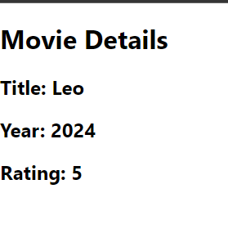

Code 1 :

const root = ReactDOM.createRoot(document.getElementById('root'));

root.render(

  <React.StrictMode>

   <Movie title ="Leo" year="2024" rating={5}/>

  </React.StrictMode>

)

const User = ({

    title="no",

    year="no",

    rating="Not Rated"

  })=> {

  return(

    <>

     <h1>Movie Details</h1>

    <h2>Title:{" "+title}</h2>

    <h2>Year:{" "+year}</h2>

    <h2>Rating:{" "+rating}</h2>

    </>

);

}

export default User;

Code:2🡺For default

const root = ReactDOM.createRoot(document.getElementById('root'));

root.render(

  <React.StrictMode>

   <Movie title ="Leo" year="2024" />

  </React.StrictMode>

);

Output 1: Output 2:

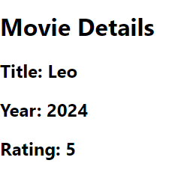 

Task 3:

Code:

 <Button label="CLICK ME"/>

Button.js:

 export default function Button(props){

    return(<>

    <button>{props.label}</button>

    </>);

}

Output:

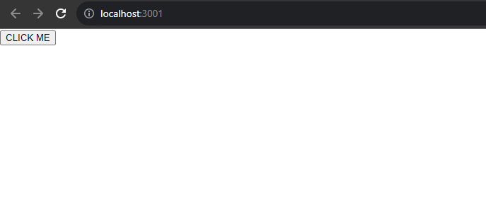

**Task 4:**

**Code:**

<UserProfile id={101} name="John" place="Coimbatore" contact="8124472399"/>

let UserProfile = (props)=>

{

return(

    <>

    <h1>User Details</h1>

    <h2>ID:{" "+props.id}</h2>

    <h2>Name:{" "+props.name}</h2>

    <h2>PLACE:{" "+props.place}</h2>

    <h2>CONTACT:{" "+props.contact}</h2>

    </>

)

}

export default UserProfile;

**Output:**

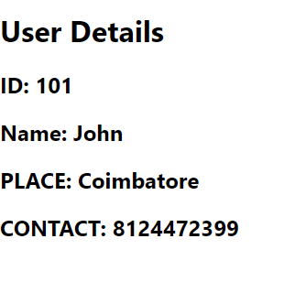

Task 5:

Code:

  <Modal title="The Road Not Taken"/>

let Modal= (props)=>{

    return(

        <>

        <h1><i><q>{props.title}</q></i></h1>

    <p >

    Two roads diverged in a yellow wood,

Robert Frost poetAnd sorry I could not travel both

And be one traveler, long I stood

And looked down one as far as I could

To where it bent in the undergrowth...

<br></br>

Then took the other, as just as fair,

And having perhaps the better claim,

Because it was grassy and wanted wear;

Though as for that the passing there

Had worn them really about the same..

<br></br>

And both that morning equally lay

In leaves no step had trodden black.

Oh, I kept the first for another day!

Yet knowing how way leads on to way,

I doubted if I should ever come back.

    </p>

        </>

    )

}

export default Modal;

Output:

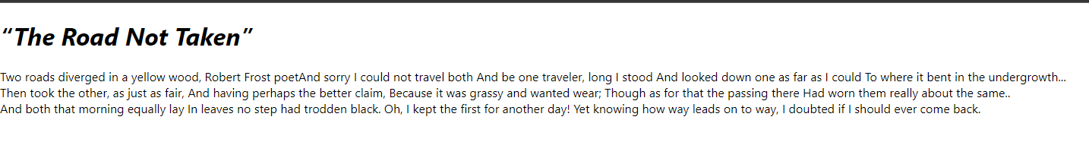

Conditional Rendering :

Task 1:

Code:

<UserStatus status="online"/>

let UserStatus=(props)=>{

return(

    <>

    <h1>User Status</h1>

     <h2>Status:

     {

(props.status == "online")? "Online" : "Offline"

    }

 </h2>

    </>

)

}

export default UserStatus;

Output 1: Output 2 :

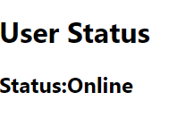 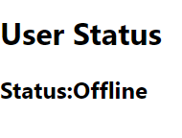

Task 2:

Code:

 <React.StrictMode>

<AgeCheck a={38}/>

  </React.StrictMode>

);

export default function AgeCheck(age){

    return(

        <>

        <h1>AGE CHECKING</h1>

         <h2>Category :

         {

    (age.a >= 18)? "Adult" : "Minor"

        }

     </h2>

        </>

    )

}

Output 1: Output 2:

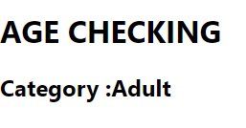 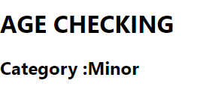

Task 3:

Code:

<Loading loading="true" />

export default function Loading(isloading){

    return(

        <>

        <h1>Loading Status</h1>

         <h2>

         {

    (isloading.loading == "true")? "Loading...." : " Not Loading......"

        }

     </h2>

        </>

    )

}

Output 1: Output 2:

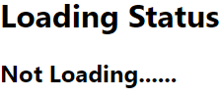

Task 4:

Code:

<Notification message="hi" />

let Notification=(

    {

      message = " "

    }

    )  =>  {

    return(

        <>

        <h1>Status of Message </h1>

         <h2> Message:

         {

   (message == " ")? message :message

         }

     </h2>

        </>

    )

}

export default Notification;

Output 1 : Output 2:

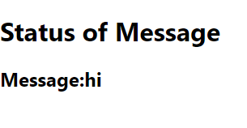 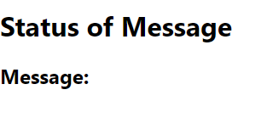

Task 5:

Code:

 <Feedback a="green"/>

export default function Feedback(props){

return (

<>

<h1>Feedback status</h1>

{

 (props.a == "green")? "Positive":"Negative"

}

</>

)

}

Output 1: Output 2 :

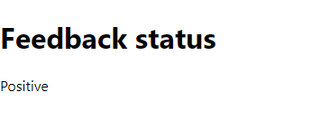 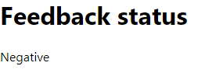

Rendering list:

Task 1:

Code:

export default function Feedback(props){

return (

<>

<h1>List Items</h1>

<ul>

{

    props.a.map( x =>(

<li>{x}</li>

     ) )

}

</ul>

</>

)

}

Output 1:

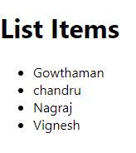

Task 2:

Code:

 <TodoList p={2}/>

export default function TodoList(props){

    let list=["Book arrangement","Reading ","Organizing chairs","Table cleaning"];

return(

    <>

    <h1>List of tasks </h1>

    <ul>

        {

            list.map(x=>

                <li>{x}</li>)

        }

    </ul>

  { (props.p==1)   && <h1> &#10004;-----Task 1 Book arrangement Completed </h1> }

   { (props.p==2) && <h1> &#10004;-----Task 2 Reading Completed </h1>}

   { (props.p==3) && <h1>&#10004;----Task 3 Organizing Chairs </h1>}

   {(props.p==4)  &&   <h1> &#10004;----Task 4 Table cleaning Completed </h1>}

    </>

)

}

Output !:

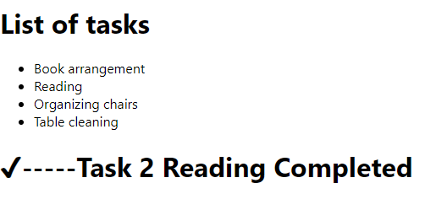

Task 3:

Code:

   < Productlist  pro={[

      {product:"20", value:"product1-$20"},

 { product:"30",value:"product2-$30"},

 {product:"6" , value:"product3-$6"},

 { product:"3", value:"product4-$3"}

]}

  />

export default function Productlist(props){

    let a=props.pro.filter(x=> x.product < 10)

    console.log(a);

   return (<>

<h1>Product with price less than 10</h1>

<ul>

    {

        a.map(x=>

            <li>{x.value}</li>)

    }

</ul>

    </>)

}

Output1:

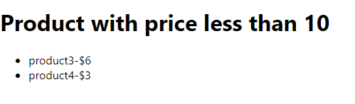

Task 4:

Code:

 <React.StrictMode>

    < UserList  pro={[

     {Username:"John",Email:"john@123gmail.com"},{Username:"Ragul",Email:"ragul@123gmail.com"},{Username:"chan",Email:"chan@123gmail.com"},{Username:"Arul",Email:"Arul@123gmail.com"}

]}

  />

  </React.StrictMode>

);

export default function UserList(props){

return(

    <>

    <h1>User Details</h1>

    <ul>

        {

            props.pro.map(x=>

                <li>{x.Username}---{x.Email}</li>)

        }

    </ul>

    </>

)

}

Output1:

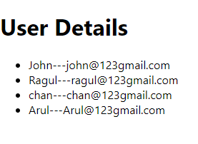

Task 5:

Code:

<React.StrictMode>

    < Shoppingcart  pro={[

      {product:"Soap", value:"$20"},

 { product:"Biscuit",value:"$30"},

 {product:"Note" , value:"$50"},

 { product:"Icecream", value:"$30"}

]}

  />

  </React.StrictMode>

);

export default function Shoppingcart(props){

    let a=props.pro.filter(x=> x.product < 10)

    console.log(a);

   return (<>

<h1>Items with price </h1>

<ul>

    {

        props.pro.map(x=>

            <li>{x.product}---{x.value}</li>)

    }

</ul>

    </>)

}

Output:

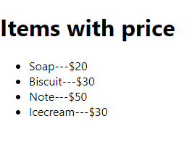

How to add markup to JavaScript with JSX :

Task1 :

Code:

<UserComponent   f={["Apple","Orange","Pineapple","Jackfruit"]} />

export default function UserComponent(props){

    return (

        <>

        <h1>List of fruits</h1>

        <ul>

            {

props.f.map(x=>

    <li>{x}</li>

    )

            }

        </ul>

        </>

    )

}

Output :

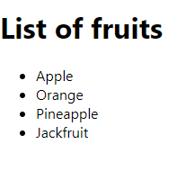

Task 2:

Code:

import pineapple from './pineapple.jpg'

import apple from './apple.jpg'

import orange from'./orange.jpg'

import jackfruit from './jackfruit.jpg'

export default function UserComponent(props){

    return (

        <>

        <h1>List of fruits</h1>

        <img  style={{width:"500px"}}src={pineapple}></img>

       <h1><figcaption>PINEAPPLE</figcaption></h1>

       <img  style={{width:"500px"}}src={apple}></img>

       <h1><figcaption>APPLE</figcaption></h1>

       <img  style={{width:"500px"}}src={orange}></img>

       <h1><figcaption>ORANGE</figcaption></h1>

       <img  style={{width:"500px"}}src={jackfruit}></img>

       <h1><figcaption>JACKFRUIT</figcaption></h1>

        </>

    )

}

Output :

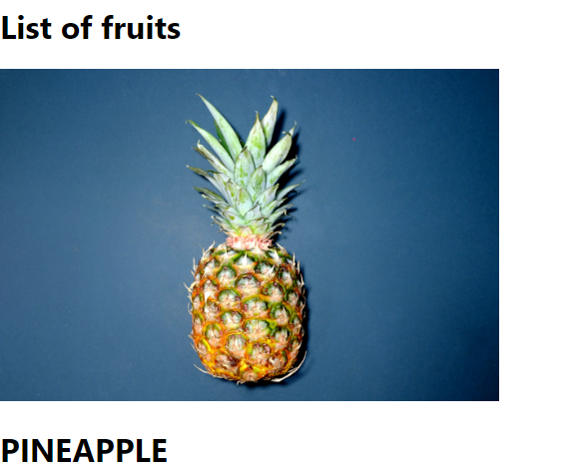 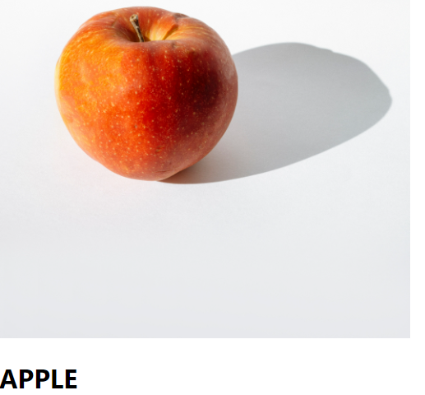

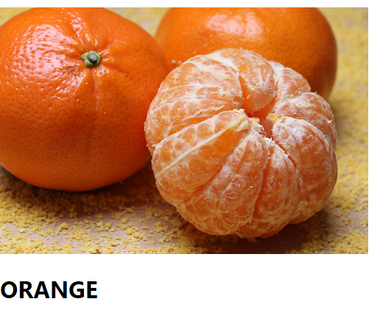 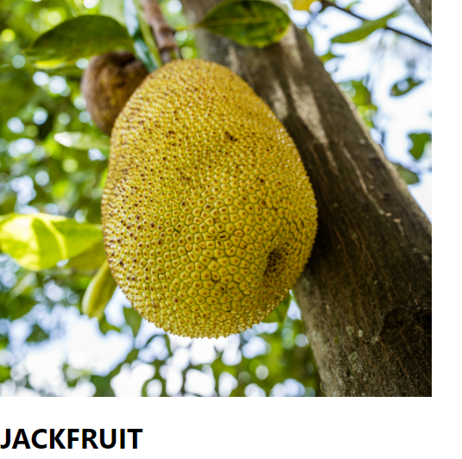

Task 3:

Code:

export default function(){

return(

    <>

    <a href="https://kce.ac.in/profile">https://kce.ac.in/profile/ </a>

    </>

)

}

Output :



Task 4:

Code:

    <Blogcomponent/>

export default function Blogcomponent(){

 return (

    <>

    <h1 style={{textAlign:"center",color:"blue"}}> Title : The Signal-Man</h1><hr></hr>

    <h2>Author : Charles Dickens</h2>

    <p>

    Written by one of England’s greatest novelists, ‘The Signal-Man’ is an eerie ghost story about a railway signal-man who is haunted by foreboding, spectral visions.

Favourite Line: ‘So little sunlight ever found its way to this spot, that it had an earthy, deadly smell; and so much cold wind rushed through it, that it struck chill to me, as if I had left the natural world.’

No doubt the best aspect of ‘The Signal-Man’ is the way Dickens establishes atmosphere. An example of this can be seen in the quotation above.

Here, Dickens succeeds in creating a haunting, supernatural atmosphere by not only suggesting the narrator has ‘left the natural world’, but also by describing the setting much like a graveyard.

    </p>

    </>

 )

}

Output :

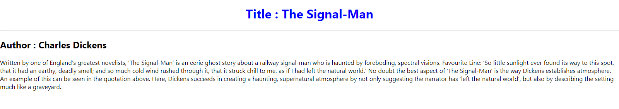

Task 5 :

Code:

<Footer/>

export default function Footer(){

    return(

        <>

        <hr></hr>

        <p>Copyright 2022 &copy; Concept by repute Last Updated on 11-08-2022</p>

        </>

    );

    }

Output :



JavaScript in JSX with Curly Braces

Task 3:

Code:

<Mathresult a={2} b={3}/>

export default function Mathresult(props){

  let a=props.a;

  let b=props.b;

  let res=a+b;

return(

    <>

    <h1>Addition operation</h1>

    <h2>{res}</h2>

    </>

)

}

Output :

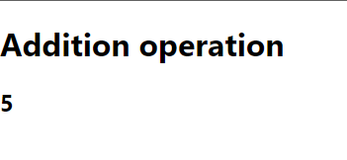

Task 4:

Code:

<User para=" At that moment a curious crack sounded inside the statue, as if something had broken.The fact is that the leaden heart had snapped right in two. It certainly was a dreadfully hard frost.’" />

-----------

export default function User(props){

   let str=props.para;

  let a=str.split([" "]);

  let len=a.length;

return(

    <>

    <h1>Words Count : {len}</h1>

    </>

)

}

Output :

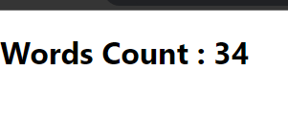

Task 5 :

Code:

export default function Mathresult(props){

  let a=props.a;

  let b=props.b;

  let res=a*b;

return(

    <>

    <h1>Product</h1>

    <h2>Product of a and b : {res}</h2>

    </>

)

}

Output:

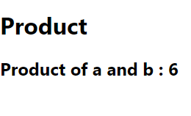

Keeping Components Pure:

Task 1:

export default function Impure(){

    let a=[2];

    return(

        <>

        <h1>{ Math.floor(  Math.random() * a.length )}</h1>

        </>

    );

}

Output :

